**EXPERIMENT NO – 04**

TITLE- FUNCTIONS IN PYTHON.

A] Program demonstrating built in functions in python.

# some buitl in functions in python

#1- absolute function

x = abs(-8.35)

print(x);

# 2- binary function

x = bin(56)

print("binary value of 56 is:",x);

# 3- boolean function

# returns always True unless value is [],{},none or 0 etc

x = bool(1200)

print(x);

# 4 - char function

x = chr(97)

print("chharacter value of 97 is:",x);

#5 - complex function (returns a complex number)

x = complex(2, 3)

print("complex number is:",x);

#6 - delete attribute function

class Student:

    name = "suraj"

    age = 21

    department = "CSE"

# delattr(Student, 'age')

print('name:',Student.name)

print('department:',Student.department)

print('age:',Student.age)

# 7 - dictionary function

x = dict(name="Suraj", lastname="Patil", dept="CSE", div="A")

print(x)

# 8 - divmod() // returns quotient and reminder while performing division operation

x = divmod(13, 2)

print("Quoteint & Reminder=",x);

# 9 - evaluate function

x = 'print(55)'

eval(x);

# 10 - exec() //same working as eval

# 11 - float() // returns a floting point number

x = float(96)

print("floating value of 96 is =",x);

# 12- id() // returns id of an object i.e. memory address

x = ('apple', 'banana', 'mango')

y = id(x)

print(y);

#13- input()

print("Enter your name:")

x = input()

print("hello, ",x)

#14- int()//returns integer number

x = int(3.35)

print("integer value of 3.35 is =",x)

#15- len()//returns length of object

mylist = ["apple", "banana", "mango"]

x = len(mylist)

print(x)

#16- max() // returns largest item

x = max(10, 15, 13);

print("largest number is:",x)

#17- min()// returns lowest value item

x = min(13, 11, 17);

print("smaller number is:", x);

#18- range()

x = range(9)

for n in x:

    print(n)

#19- round()//rounds a number

x = round(5.453892, 2)

print("rounding value upto 2 digit is:",x)

#20- soted()//returns a sorted list

list =("a", "d", "b", "c")

x = sorted(list)

print(x);

#21- sum()//returns sum

a = (3,4,5,6,7,8)

x = sum(a)

print("sum is =",x)

#22- type() // returns type of an variable or datatype

a = {5,10,15,20,25}

b = ["apple", "banana", "mango"]

c = 33

d = 56.24

print("data-type of a is:",type(a));

print("data-type of b is:",type(b));

print("data-type of c is:",type(c));

print("data-type of d is:",type(d));

output:

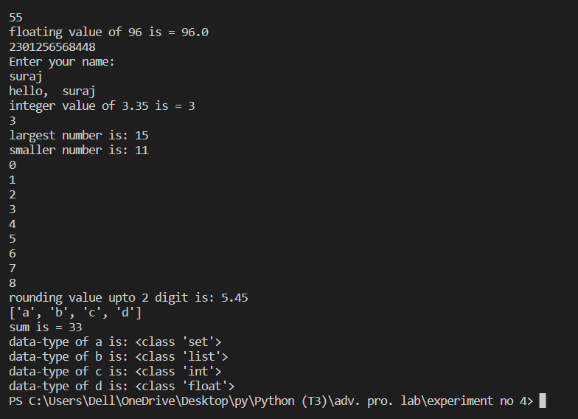

B] Function with min 2 arguments.

#1- function with 2 arguments

def myself(name,sirname):

    print(name,"",sirname)

myself("Suraj", "Patil")

#2- functions with 3 arguments

def volume(length, breadth, height):

    volume = length*breadth*height

    print("volume is =",volume,"unit")

volume(10, 5, 15)

def interest(amount,rate,time):

    interest=(amount*rate*time)/100;

    print("interest=",interest)

interest(100,13,2)

#3- function with multiple arguments

def addition(x,y):

    print("addition is:",x+y)

addition(10,20)

#user input

def addition():

    x=int(input('enter first number:'))

    y=int(input('enter second number:'))

    print("addition is:",x+y)

addition()

#average

def average(m1,m2,m3,m4,m5):

    sum=m1+m2+m3+m4+m5

    avg=sum/5

    print('sum=',sum,'average=',avg)

average(10,20,30,40,50)

output:

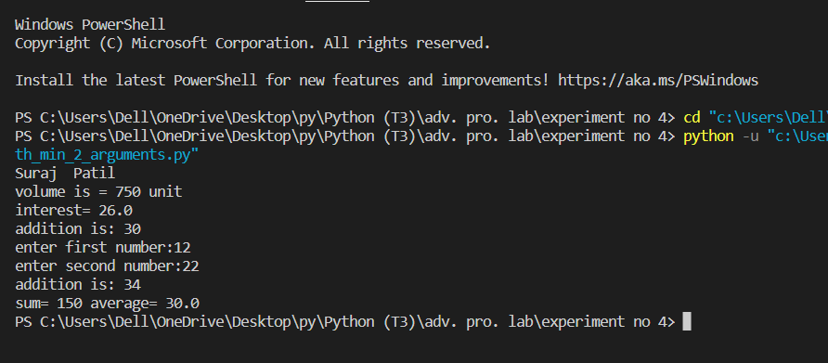

3] Function returning values.

# 4.c_function returning values

def fun1(x):

    return 2 * x

print("5*2=",fun1(5))

print("7*2=",fun1(7))

print("8*2=",fun1(8))

def fun2(x):

    return x**2

print("square of 2 is:",fun2(2))

print("square of 3 is:",fun2(3))

print("square of 5 is:",fun2(5))

output:

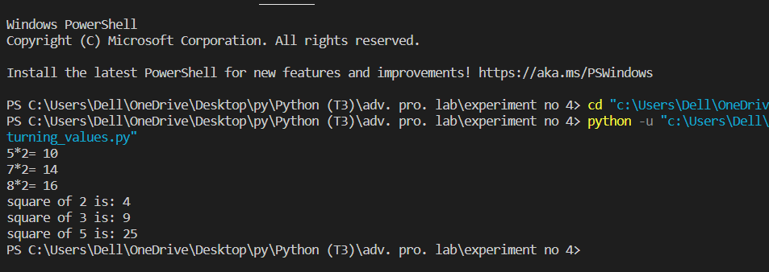

4] Operations on list, tuple, dictionary and set

# 1-list

a = [10,20,30,40]

print("a[3]=",a[3])

print("A[0]=",a[0])

print("a[1] to a[3] ==>",a[1:3])

print("from -- to all==>",a[0:])

# printing data type of a

print(type(a))

a[2]= 17#replacing 30 with 17

print(a)

# 2-Touple

t = (5,'welcome',1+3J)

print("t[1]==>",t[1])

print("all==>",t[0:])

print(type(t))

# 3-Dictionary

dict = {}

dict['one'] = "This is one"

dict[2] = "This is two"

tinydict = {'name': 'john','code':6734, 'dept': 'sales'}

print(dict['one']) # Prints value for 'one' key

print(dict[2])# Prints value for 2 key

print(tinydict)# Prints complete dictionary

print(tinydict.keys())# Prints all the keys

print(tinydict.values())# Prints all the values

# 4-Set

myset ={'apple','banana','mango'}

print(myset)

print(type(myset))

myset.add('orange') #adding elemnt to existing set

print(myset)

for x in myset:print(x)#it will print all elements in set as a list

print('banana' in myset) #it will return True

myset.remove('apple')#removing element from set

print(myset)

output:

